Project proposal for the CS F 472 class, Spring Semester 2013
UAF Contacts;
Bob Van Veldhuizen, research tech/teaching assistant
School of Natural Resources and Agricultural Sciences
327 O’Neill Resources Building
474-5222
rmvanveldhuizen@alaska.edu
Dr. Mingchu Zhang, Department Head, High Latitude Agriculture
School of Natural Resources and Agricultural Sciences
321 O’Neill Resources Building
474-7004
mzhang3@alaska.edu

Course: NRM-380 Soils and the Environment.
Background: This course is an introductory soils class designed to introduce our students to many different concepts of soil science. One of the tools we've been using is an old computer model that simulates the carbon and nitrogen cycles in a forest ecology. It is a simple program that allows the user to enter various carbon and nitrogen variables to predict the final carbon and nitrogen balance after a number of forest rotations. Dr. Dave Valentine brought this model with him when he was teaching the class back in the 1990's. He got it from his fellow grad students Steve Hart and John Pye and their advisor Dan Binkley back at Duke University. They originally wrote it specifically as a teaching tool for undergraduate forest soils students in the mid 1980's to help students learn about management impacts on forest re-growth through changes in nitrogen cycling and to provide an opportunity to learn about the strengths and weaknesses of simple simulation models. Dr. John Pye was the last one to upgrade this computer program (way back in 1988) at the Department of Forest and Wood Sciences, Colorado State University. He and the original grad students specifically did not copyright the program as they wanted it used for teaching, so it is in the public domain without copyright issues. To the best of our knowledge none of them have upgraded the program since then. It is called FORNUTS (FORNUTS - FORest NUTrient Simulation) and was written in Fortran. It was designed to be operated on a PC through the old DOS system using the 3.5 in floppy drive on which the model is written on. Up until a few years ago it was still fairly easy for students to use the model on any of the PC's we have in our teaching lab. Now however with all the upgrades in computers and software operating systems that has become much more difficult. We are left with passing around an old laptop that still has both Windows 95 and a 3.5 in floppy drive.
There is a paper copy of the programs line by line Fortran code. There is also a copy of that file on each 3.5 in floppy disk that we got from him all those years ago labeled FORNUTS.for. I don't know if that is accessible or not as it might be a read only file.
What we would like is to have this model be able to be run in a Windows environment (any environment and not be limited to Windows 95) instead of the old DOS environment to make it easier for our students to use as a learning tool.

The FORNUTS Model: This model simulates production, in kilograms of biomass per hectare, in a southern loblolly pine plantation (Pinus tadea) as affected by changes in nitrogen availability over time. Stand growth, for up to five rotations, is modeled as a function of two variables: site index (how tall the trees will be after a certain number of years) and soil nitrogen availability. This soil nitrogen availability will have a direct effect on the stands potential annual growth. When soil nitrogen levels become too low (below a baseline level), then annual stand growth will be reduced.
The model will provide tables that summarize the changes in soil nitrogen levels and harvested biomass for each rotation and a final overall summary at the end of the simulation. You can change some of the models parameters for each run such as; the site index at 25 years (in feet), the soil carbon and nitrogen contents, the nitrogen levels of the biomass, annual nitrogen inputs (fertilizers) and outputs (leaching), a variety of stand treatments (fire, harvest, etc.) and rotation lengths. This will allow you to see what the affects on the stand are for various management decisions. Figure 1 is a flow chart of the FORNUTS model showing the steps the simulation goes through in determining the changes in stand biomass and nitrogen for the run.
 |  | User Initializes Model Variables
 |  | ↓
 |  | Begin Simulation
→→→→ | →→→→→→→→ | →→→→↓
↑ |  | Prescribed Burn ?
↑ |  | ↓
↑ |  | Fertilization ?
↑ |  | ↓
Repeat Annual Cycle |  | Calculate Baseline Growth
↑ |  | ↓
↑  ↑  ↑ | No←←←←  ↓ | Does Available Nitrogen Meet Growth Demand ? | →→→→Yes  ↓
↑ | ↓ |  | ↓
↑  ↑  ↑ | Reduce Growth Until It Matches Nitrogen Levels |  | ↓  ↓  ↓
↑ | ↓ |  | ↓
↑  ↑ | ↓→→→→ | Increase Stand Biomass | ←←←←↓
↑ |  | ↓
↑  ↑ | No←←←←  ↓ | Harvest ? | →→→Yes→→→ | Whole Tree or Stem Only ?
↑ | ↓ |  |  | ↓
↑ | ↓ |  |  | Slash Burn ?
↑ | ↓ |  |  | ↓
↑  ↑ | ↓  ↓ |  |  | Print Rotation Summary
↑ | ↓ |  |  | ↓
↑←←←← | Annual Nitrogen Input and Output | ←←←←←←←← | ←←←Yes←←← | More Rotations ?
 |  |  |  | ↓
 | Stop | ←←←←←←←← | Print Summary of Entire Simulation | ←←←←No
Figure 1. The flow chart for the FORNUTS model.

The FORNUTS model uses four site index curves (75, 65, 55 & 45) for southern loblolly pine, (Figure 2). Biomass will continue to build-up along these curves if soil nitrogen is not limiting. An oversupply of soil nitrogen will not result in growth greater than the curves. The only affect of soil nitrogen is the rate of biomass accumulation along each of the four site index curves. This growth rate is regulated by the use of a “physiological age” of the stand even though a true age is incremented for each year of the rotation. For example, if nitrogen levels are not limiting then stand development increases along the site index curve at a rate of one physiologic year for each true year. When soil nitrogen is limiting then stand development increases along the curve at something less than one physiologic year for each true year.
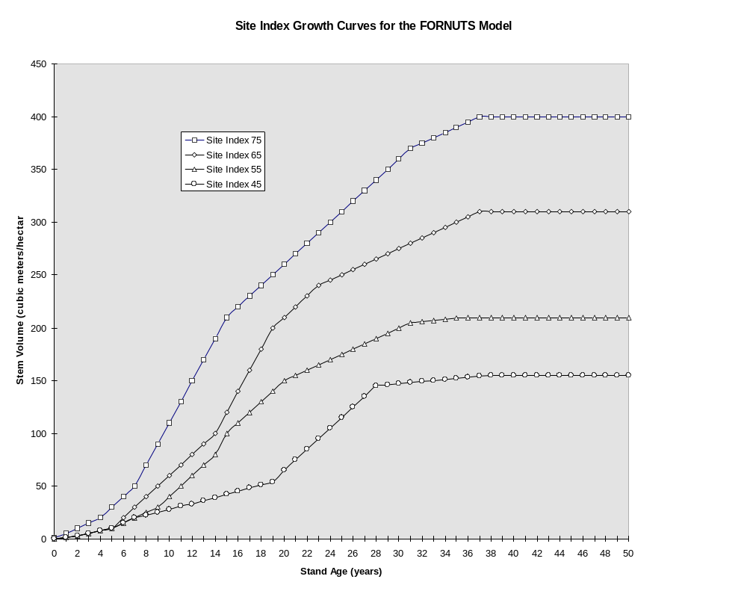Figure 2. The site index curves for the FORNUTS model.

The effects of stand treatments like prescribed burning or fertilization allow the stand to develop at a rate of physiological years greater than true years. The temperature of the fire (hot vs. cool) will stimulate growth but can also reduce the overall soil nitrogen content. For example, cool fires will decrease total soil nitrogen content less than a hot fire. However, the hotter fire will stimulate growth for a longer time period because more nitrogen is made available. This would result in a net decrease in productivity. In this model, hot prescribed burns reduce soil nitrogen levels by twice as much as cool burns, 40 kg vs. 20 kg of N, respectively. In addition, hot slash burns will volatilize twice as much nitrogen from the remaining biomass as cool burns, 150 kg vs. 75 kg N.
For each year of the rotation, the nitrogen inputs and outputs are determined. These pathways include precipitation, fixation, fertilization, burning, leaching, and harvesting. Any soil nitrogen not taken up during the year is returned to the soil nitrogen pool. In real systems this extra nitrogen would most likely be lost due to leaching. With FORNUTS, leaching losses are set at the beginning of the run and remain constant. All changes in the nitrogen pools are totaled at the end of each rotation. The amount of carbon in the system is determined at the beginning of a simulation run and remains constant. It is assumed to equal 50% of the total organic matter.
Nitrogen availability, as a function of net mineralization, is determined by the carbon nitrogen ratio (C:N), and the soil nitrogen content. Nitrogen mineralization (kg/ha/yr) is low for sites with a high C:N ratio and low total soil nitrogen, and high for sites with a low C:N ratio and high total soil nitrogen. Additional inputs of fertilizer are combined with the mineralized nitrogen pool in the year that it is applied. Any of this fertilizer not taken up that year is added to the total soil nitrogen pool for use in subsequent years. In this model, the extra nitrogen from fertilization provides very small increases in availability over the rotation period. In a real system, this pool would provide stimulated growth for a longer period of time.
The biomass of the tree is broken down into compartments of fine root, coarse root, main stem, branches and foliage (the leaves remain on the trees for two years before becoming litterfall). Harvesting of the trees can be of main stem only or whole tree. In harvesting the stem only, the biomass and nitrogen in the stems are removed and the remaining biomass nitrogen is transferred back into the soil nitrogen pool. In whole tree harvesting, the nitrogen in the coarse roots, branches and foliage is removed and not returned to the pool. One half of the total foliage and all of the fine root biomass is considered to be litterfall. Some of the nitrogen within this litterfall biomass is considered unavailable, the remainder is added back into the total pool of available nitrogen. The model will calculate the nitrogen required for growth for each biomass compartment as the difference between the biomass produced for the previous year and this year’s biomass times the percent nitrogen in each compartment. Other remaining compartments are assumed to grow linearly as a function of the physiologic age to some predetermined maximum level and then to remain constant until harvested. In real systems, growth rates are not necessarily linear, so biomass accumulation would be vastly different.

Using the Model: The model was coded in FORTRAN computer language in the Disk Operating System (DOS) in the days before multi-megabyte machines existed on people’s desks, so the CPU and memory requirements are very modest - even an old IBM PC will do fine. After turning on the computer, open the DOS Command Prompt window (under Windows 95 and later versions, select Start\Programs\Accessories\Command Prompt or click on the MSDOS icon). To get to the hard drive type cd..<enter>. Continue typing in this DOS command until the prompt, C:\> is on the screen (this should take at least two steps). Next, type cd fornuts<enter> after the C:\> prompt. This DOS command changes the directory to the FORNUTS model on the hard drive. You should now have the prompt, C:\FORNUTS> in the DOS Command Prompt window. To start the model, simply type FORNUTS<enter> after the C:\FORNUTS> prompt. Maximize the window then answer the questions after each prompt. For the first run, use the parameter values listed in Figure 4 for each question, (see Figure 3 for the range of possible values for each parameter and if a decimal point must be entered along with the value). After you have entered all the values after each prompt the model will run through a quick couple of screens with the data entered and then ask if everything is correct. If you answer “no” then you will have to re-enter every value over again not just the one where you made a mistake. So, pay close attention to the values as you are entering them along with a decimal point, if needed. Once the model is running a number of screens will flash by way too fast to actually read them. They will contain the data from the first rotation (Figure 5), the second rotation (Figure 6), and the final summary for the simulation (Figure 7). The final summary is the screen of interest as it contains the results of the simulation as far as net changes in the nitrogen pool and biomass yields. At the end of the model run, you are asked to press<ctrl><PrintScrn> if you want a printout.

Question | Recommended Ranges
ENTER INITIAL RANGE | 0 to 50 (years)
SITE INDEX | 45,55,65 or 75 (Must be one of four)
ROTATION LENGTH | 25 to 75 (years)
NUMBER OF ROTATIONS | 1 to 5
AGE FOR FERTILIZATION | 0 = no fert or anytime, but only once for each rotation
RATE OF FERTILIZATION | 0 = not fertilizing or 100, 200 or 300 (kg/ha)
AGE OF FIRST PRESCRIBED BURN | 0 = never or anything beyond 10 (years)
FREQUENCY OF BURN | 0 = no burn or between 4 and 20 years
BURN INTENSITY | 0 = no burn, 1 = warm burn, 2 = hot burn
HARVEST METHOD | 1 = whole tree, 2 = stem only
SLASH BURN | 0 = no burn, 1 = burn
SLASH FIRE INTENSITY | 0 = no burn, 1 = warm burn, 2 = hot burn
PERCENT OF LEAF N REABSORBED | 0. to 40. (include decimal point)
PERCENT OF ROOT N REABSORBED | 0. to 40. (include decimal point)
RATIO ROOT BIOMASS:LEAF BIOMASS | 50. to 200. (as %), (include decimal point)
TOTAL SOIL CARBON | 15000 to 35000 (kg/ha)
TOTAL SOIL NITROGEN (C/N ratio ranges = 10:1 to 20:1) | 1500 to 5000 (kg/ha)
PERCENT N IN FOLIAGE | 0.8 to 2.0 (include decimal point)
PERCENT N IN FINE ROOTS | 0.5 to 1.2 (include decimal point)
ANNUAL N INPUTS | 5 to 20
ANNUAL N LOSSES | 1 to 5
CHANGE ANY OF THE ABOVE PARAMETERS? | 0 = no, 1 = yes
Figure 3. The FORNUTS model questions that occur after each prompt and the recommended ranges for input, (listed as the file LEGEND.TXT in the FORNUTS folder on the 3.5 in floppy).

USER CONTROLLED SIMULATION PARAMETERS
-------------------------------------------------------------------
SIMULATION PERIOD: | 39 YEARS
NUMBER OF ROTATIONS TO BE SIMULATED: | 2
INITIAL STAND AGE: | 1 YEARS
ROTATION LENGTH: | 20 YEARS
SITE INDEX: | 75
SOIL CARBON POOL: | 30000. KG/HA
INITIAL SOIL NITROGEN POOL: | 2000. KG/HA
PERCENT N IN FOLIAGE: | 1.20 %
PERCENT N IN FINE ROOTS: | 1.00 %
PERCENT N REABSORBED  PRIOR TO LEAF ABSCISSION: | .50 %
PERCENT N REABSORBED  PRIOR TO SENESCENCE OF FINE ROOTS: | .50 %
Pause
Please press <return> to continue
PERCENT OF FINE ROOTS TO FOLIAGE: | 100.00 %
ANNUAL N INPUT: | 3. KG/HA
ANNUAL N OUTPUT: | 1. KG/HA
N FERTILIZATION? | YES
N FERTILIZATION RATE: | 200 KG/HA
STAND AGE WHEN FERTILIZED: | 15 YEARS
PRESCRIBED BURNING? | YES
INITIAL STAND AGE WHEN  FIRST PRESCRIBE BURN: | 15 YEARS
FREQUENCY OF PRESCRIBED BURNS: | EVERY 5 YEARS
RELATIVE TEMPERATURE OF PRESCRIBED BURNS: | WARM
SLASH BURNING? | YES
RELATIVE TEMPERATURE OF SLASH BURNS: | WARM
HARVEST METHOD: | WHOLE TREE
Figure 4. Data for the first test run of the FORNUTS model, (listed as the file INPUT0.TXT in the FORNUTS folder on the 3.5 in floppy).
By now most students are probably frustrated with how long and tedious running the model in DOS can be - especially if they made any mistakes. Moreover, most of the output zoomed past the screen far too fast to be useful, (unless they echoed the output to a printer providing a tangible boost to the paper industry). Fortunately, there is a better way that saves time, paper and nerves. The model can use data input and output files and DOS piping (Text Editor) to make data input and output easier to manage. To do this, you will need to open another window that contains all the files in the FORNUTS folder on the 3.5 in floppy, select Start\My Computer\Local Disk (C:) then double click on the FORNUTS folder to bring up all the files located in the folder. The initial data input text file has been created labeled INPUT0.TXT, (Figure 4). Double click on it to open it as another window. This data set is the same data in the same order (complete with <entry> commands) as what was entered by keyboard in the practice run. Reading the data input file by itself is not very informative, so there is a text file in the FORNUTS folder on the 3.5 in floppy labeled LEGEND.TXT, (Figure 3). If you double click on that file to open it as yet another window on the screen you can move both the input and legend windows around so that the variables in the legend will line up with the numbers in the input file (this will also make it easier to make any changes to the input file for later simulations).
SUMMARY OF NITROGEN BUDGET AND BIOMASS YIELDS BY ROTATION
-------------------------------------------------------------------------------------------------------------------------
SIMULATION YEAR: |  | 19
INITIAL AGE OF STAND: |  |  | 1
ROTATION NUMBER: |  |  | 1
INPUTS OF NITROGEN TO SITE (KG/HA) |  |  |  |  | OUTPUTS OF NITROGEN FROM SITE (KG/HA)
--------------------------------------------------------- |  |  |  |  | -----------------------------------------------------------------
FERTILIZATION: |  |  | 200. |  | SLASH BURNING: |  | 0.
PRECIPITATION: |  |  | 57. |  | PRESCRIBED BURNING: |  | 80.  160.
 |  |  | ---------- |  | LEACHING: |  | 19.
TOTAL: |  |  | 257. |  | LOSSES FROM BIOMASS REMOVALS
 |  |  |  |  | STEMS: |  | 10.73
 |  |  |  |  | COARSE ROOTS: |  | 2.05
 |  |  |  |  | FOLIAGE: |  | 30.78
 |  |  |  |  | BRANCHES: |  | 9.41
 |  |  |  |  |  |  | ----------
 |  |  |  |  | TOTAL: |  | 52.46
NET CHANGE IN TOTAL NITROGEN OF SITE (KG/HA): |  |  |  |  |  | 106.
SOIL NITROGEN POOL AT END OF SIMULATION (KG/HA): |  |  |  |  |  | 2106.
CARBON:NITROGEN RATIO AT END OF SIMULATION: |  |  |  |  |  | 14.
BIOMASS YIELDS (KG/HA)
--------------------------------------
STEMS: | 10227.
COARSE ROOTS | 2045.
FOLIAGE: | 2565.
BRANCHES: | 2850.
 | ------------
TOTAL: | 17688
BIOMASS YIELD PER UNIT OF NITROGEN REMOVED: |  |  |  |  |  | 337.
Figure 5. Page 1. of OUTPUT0.TXT for the first rotation of the simulation.
To use this input file with the model, type after the C:\FORNUTS> prompt FORNUTS<INPUT0.TXT>OUTPUT0.TXT<enter> (exactly as it is written, including the < and > signs). This time, the model will use the data in the text file INPUT0.TXT instead of keyboard entries, and will send all the output to a new text file labeled OUTPUT0.TXT, (Figures 5 through 7). This output file should show up as a new file located in the FORNUTS folder. To open it, double click on the file and scroll through until you find the final summary with the results of the simulation with the net changes in the nitrogen pool and biomass yields. At this point the students can highlight the final summary page, copy it, and paste it into a Microsoft Word document for printing.
SUMMARY OF NITROGEN BUDGET AND BIOMASS YIELDS BY ROTATION
-------------------------------------------------------------------------------------------------------------------------
SIMULATION YEAR: |  | 39
INITIAL AGE OF STAND: |  |  | 0
ROTATION NUMBER: |  |  | 2
INPUTS OF NITROGEN TO SITE (KG/HA) |  |  |  |  | OUTPUTS OF NITROGEN FROM SITE (KG/HA)
--------------------------------------------------------- |  |  |  |  | -----------------------------------------------------------------
FERTILIZATION: |  |  | 200. |  | SLASH BURNING: |  | 75.
PRECIPITATION: |  |  | 60. |  | PRESCRIBED BURNING: |  | 80.  160.
 |  |  | ---------- |  | LEACHING: |  | 20.
TOTAL: |  |  | 260. |  | LOSSES FROM BIOMASS REMOVALS
 |  |  |  |  | STEMS: |  | 10.50
 |  |  |  |  | COARSE ROOTS: |  | 2.10
 |  |  |  |  | FOLIAGE: |  | 31.05
 |  |  |  |  | BRANCHES: |  | 9.49
 |  |  |  |  |  |  | ----------
 |  |  |  |  | TOTAL: |  | 53.14
NET CHANGE IN TOTAL NITROGEN OF SITE (KG/HA): |  |  |  |  |  | 32.
SOIL NITROGEN POOL AT END OF SIMULATION (KG/HA): |  |  |  |  |  | 2137.
CARBON:NITROGEN RATIO AT END OF SIMULATION: |  |  |  |  |  | 14.
BIOMASS YIELDS (KG/HA)
--------------------------------------
STEMS: | 10503.
COARSE ROOTS | 2101.
FOLIAGE: | 2588.
BRANCHES: | 2875.
 | ------------
TOTAL: | 18067
BIOMASS YIELD PER UNIT OF NITROGEN REMOVED: |  |  |  |  |  | 340.
Figure 6. Page 2 of OUTPUT0.TXT for the second rotation of the simulation.
SUMMARY OF NITROGEN BUDGET AND BIOMASS YIELDS FOR ENTIRE SIMULATION
-------------------------------------------------------------------------------------------------------------------------
INPUTS OF NITROGEN TO SITE (KG/HA) |  |  |  | OUTPUTS OF NITROGEN FROM SITE (KG/HA)
---------------------------------------------------------- |  |  |  | ------------------------------------------------------------------
FERTILIZATION: |  | 400. |  | SLASH BURNING: |  | 75.
PRECIPITATION: |  | 117. |  | PRESCRIBED BURNING: |  | 160.
 |  | ---------- |  | LEACHING: |  | 39.
TOTAL: |  | 517. |  | LOSSES FROM BIOMASS REMOVALS
 |  |  |  | STEMS: |  | 20.73
 |  |  |  | COARSE ROOTS: |  | 4.15
 |  |  |  | FOLIAGE: |  | 61.83
 |  |  |  | BRANCHES: |  | 18.89
 |  |  |  |  |  | ----------
 |  |  |  | TOTAL: |  | 105.60
NET CHANGE IN TOTAL NITROGEN OF SITE (KG/HA): |  |  |  |  | 137.
SOIL NITROGEN POOL AT END OF SIMULATION (KG/HA): |  |  |  |  | 2076.
CARBON:NITROGEN RATIO AT END OF SIMULATION: |  |  |  |  | 14.
BIOMASS YIELDS (KG/HA)
--------------------------------------
STEMS: | 20731.
COARSE ROOTS | 4146.
FOLIAGE: | 5153.
BRANCHES: | 5725.
 | ------------
TOTAL: | 35755
BIOMASS YIELD PER UNIT OF NITROGEN REMOVED: |  |  |  |  | 339.
Figure 7. Page 3 of OUTPUT0.TXT for the final summary from the first simulation of the FORNUTS model.

At this point, students can use this DOS text editor to change the data input file or review the model output file. When they do make any changes to a data input file, they will need to save it with a different name, (e.g. for the baseline run call the data file INPUTB.TXT and the associated output file OUTPUTB.TXT). Use the Save As command in the text editor to do this. INPUT0.TXT is write-protected so it cannot be changed by accident.
The purpose of the exercise is to familiarize students with how aspects of the nitrogen cycle affect and are affected by management practices, while at the same time learning the limitations of simulation modeling. To do this, they need to perform a number of different simulation runs where some variables (management decisions) are changed to compare and contrast the results (biomass and soil nitrogen levels). If anything goes wrong with the editing for each of the runs, they can always go back and start with the INPUT0.TXT file.

